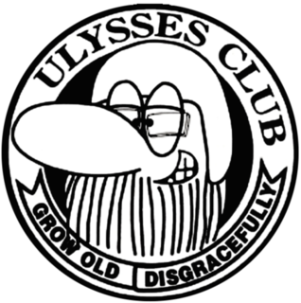

Taranaki Branch Ulysses
Wednesday 17th of Oct 2018
Venue: NP Club
Meeting Started: 6:03pm

Present: Andrew P, Suzie P, Alan F, Graeme W, Gemma P, Martin P, Harry B, Bill K, Blair C
Present at Social Night: Ray and Anne Senior, Janice W, John N and Pam, Helen B, Joy C, Margaret K, Newt, Wendy H, Jeff , Betty.
Apologies: Donna and Nigel S
- Minutes | Passed: true and correct: Andrew P, Martin P
- Matters Arising | An example rally badge will be ready for the next rally meeting – 31st Oct
- Correspondence | None In or Out
- Financial Report (Harry) | See written report  Discussed the Term Deposit  Moved that we move to electronic bank statements Harry/Blair  Passed Harry/ Graeme
- Presidents Report  (Suzie) | - November meeting in South Taranaki. Donna has booked us into Rough Habits for 6pm. Need to get numbers a few days before.  - Donna has communicated via text that she and Nigel are flat out with their new roles in R.A.T.S Taranaki and Aotearoa and doing suicide support work etc. They are feeling that they are not able to keep up their roles on the committee. Discussed the huge amount of work they have been doing over the past year for R.A.T.S and the roles Donna held. Andrew will take over the Facebook requests. Graeme will talk to Janice about supporting him with the Secretary role. Suzie to contact Donna and Nigel to make sure all OK and to thank them for their work for Ulysses Taranaki. Their enthusiasm and new ideas helped to refresh our branch and we will continue to benefit from these ideas well into the future. We hoped they would stay in the club, as we have enjoyed their company and Suzie will communicate this to Donna and Nigel as well.  - Movie and Dinner night that replaced our Sept meeting was well attended and went off well.  - Passed Suzie/ Alan
- Rides  (Martin) | - Current Rides Committee – Martin, Andrew, Alan, Bill, Ray  - Overnighter to Taihape next weekend is all sorted – October Labour Weekend. Discussed various routes and settled on the ride down as the monthly club ride. Suzie will share this via text. Lunch at Cheltenham Hotel, Fielding.  - Discussed taking flags on rides for PR. We purchased a number of flags and various rides committee folk have them. They need to remember to bring them along to display.  - Discussed Rides List. Gemma will update the Website as needed.  - Will have next Rides committee meeting early in 2019.
- General Business | - Rally – Blair shared that we now have 46 registrations! Next meeting is at Blair and Joys on 31st October.  - Xmas Function – Chose date for Saturday 15th December. Everyone to think about what we could do and discuss at Nov meeting in Hawera.  - PR – Discussed doing more PR. Ideas: Display flags and banners on rides, Attend more big events, do some volunteering, give all members Ulysses business cards to hand out, wear our vests more often. Martin challenged all committee members to find a summer event we can do PR at.
Meeting closed 6:46 pm

Next meeting: Wed 21st November 2018 at Rough Habits, Hawera

